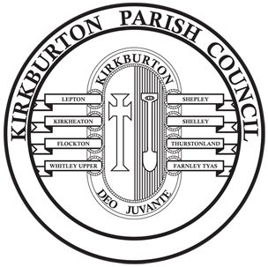
KIRKBURTON PARISH COUNCIL
Burton Village Hall, Northfield Lane, Highburton, Huddersfield HD8 0QT
Tel: 01484 604391. Email: admin@kbpc.co.uk

VILLAGE IMPROVEMENT FUND
PROJECT FORM 2025-26
Parish Council Ward:
Parish Councillors Involved:

The deadline dates for returning the completed form with the quotes and any other supplementary information are: 4 July 2025, 24 October 2025 and 6 February 2026.
.
1 | Please provide the name of the organisation or individual promoting the project. This can also be a Parish Councillor (s)  If it is an organisation, the name must be the same as that shown on the bank account.
2 | Please tell us what your project is about and show how this will improve life in your village.
3 | Please indicate how long you think your project will take to deliver and when you would expect it to be completed.
4 | What arrangements are you putting in place to ensure that the project is completed on time and delivering the village improvement?
5 | Please show the costs of the proposed project and how it is expected that this cost will be met.  £  £  £  Total Cost £  Please ensure you provide quotes for all of the above items.  Met by:  - Parish Councillor’s Contribution £  Maximum of £500 per Councillor  - Other contributions (please specify): £  TOTAL FUNDING £
Internal Use Only:

Date & Minute No when the application was considered by the Committee:

Date Council Approval was given:

Date Funding was issued:

Please print this on a separate page, as it needs to be separated from the rest of the form before circulating to the Committee in order to comply with the Data Protection legislation
Please provide details of the main contact within the organisation for the project

Name:

Daytime Phone Number:

Email Address:
Please ensure any capital letters, underscores and full stops are clear.

Full Postal Address inc post code (unless the contact is a Parish Councillor):

If the project is being carried out by a community group, please provide the bank details below:
Account Name:

Sort Code: Account No:
Type of Account eg community, deposit, business, etc:

Have these details changed from those previously supplied? Yes / No
NB: The Council does not retain groups’ bank details, but if they have changed, the Council will have to re-register the group at the bank before it can make the transfer.
Please ensure that the name is exactly as on the statement, or the transfer cannot be made.

I confirm that the Parish Councillor/s involved have given consent to the project.

Signature …………………………………………………………………………………

Position within the promoting organisation ……………………………………………
Date …………………….
All details provided within this form will be dealt with in accordance with data protection legislation. A copy of the Council’s Privacy Notice can be viewed on the website and is available on request.

